Ideation Phase
Empathize & Discover
Date | 29 September 2026
Team ID | SWTID-2026-2597
Project Name | Streamlining IT Procurement – Automating Standard Laptop Orders with Flow Designer
Maximum Marks | 4 Marks
Empathy Map Canvas
The empathy map captures the needs, expectations, actions, pain points, and gains of users involved in requesting and processing a Standard Laptop. It helps the team understand the user experience before designing the automated workflow.
THINK & FEEL | SEE | HEAR
Wants quick fulfilment  Needs clear request status  Concerned about delays | Service Catalog item  Approval status  Requested Item and Catalog Task | Approval updates  Hardware team updates  Configuration status
SAY & DO | PAIN | GAIN
Empathy Insights
- The requester expects a predictable process from order placement to laptop configuration.
- The Hardware team needs a clearly assigned Catalog Task with the correct description.
- The approval stage should be visible before configuration work begins.
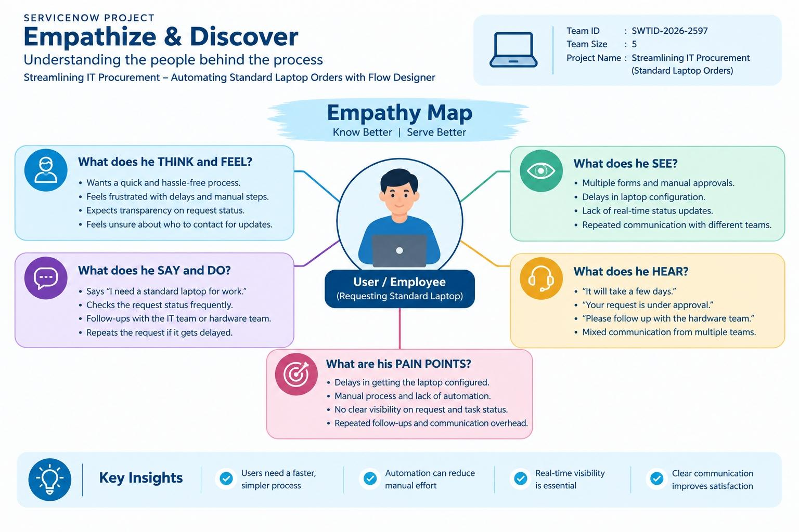
- Automation should reduce repeated manual steps and improve process visibility.

Expected User Experience

- Place the Standard Laptop order through Service Catalog.
- Complete the required approval.
- Generate the Requested Item and trigger the Standard laptop task Flow.
- Automatically create and assign the Catalog Task to Hardware.
- Begin laptop configuration without unnecessary manual handoff.
Connection to the Solution
The empathy findings support the proposed ServiceNow solution: Flow Designer automatically creates the Catalog Task, sets the required short description, assigns it to the Hardware group, and carries the approved request into the configuration workflow.

